Medical Care Development, Inc.
11 Parkwood Drive, Augusta, Maine 04330
www.mcd.org

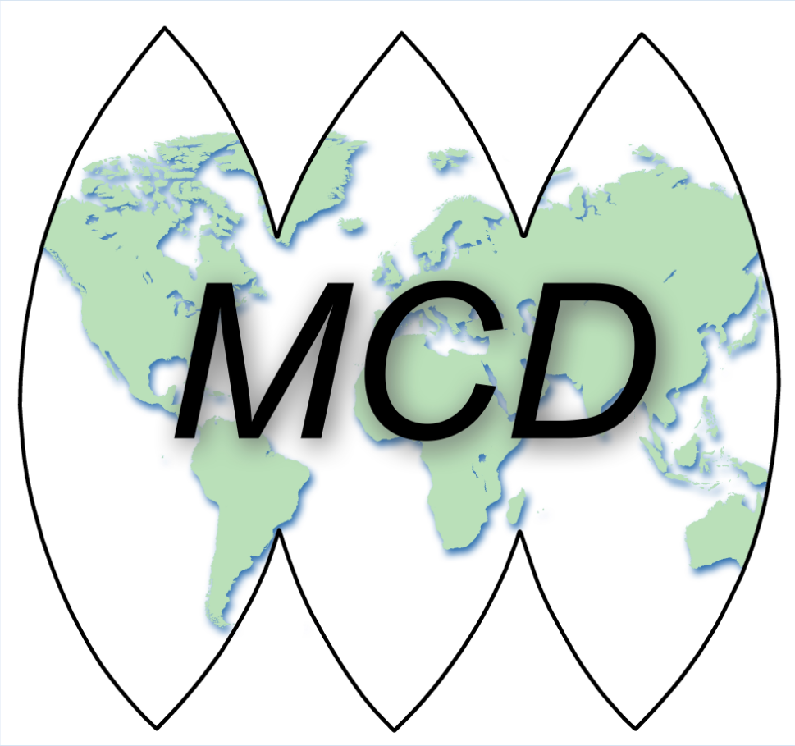

… instilling hope … reclaiming lives … attaining dreams

POSITION ANNOUNCEMENT

Project Manager – Maternal and Infant Substance Use Prevention Coordination

Do you have a passion for public health in relation to Maternal and Infant Substance Use Prevention Coordination in the State of Maine? Medical Care Development, Inc. (MCD), a non-profit public health services organization is accepting applications for a Project Manager for the Maternal and Infant Substance Use Prevention Coordination. This position works to develop and implement a state-wide strategic plan for substance exposed infants (SEI) (including Fetal Alcohol Spectrum Disorder (FASD)) prevention, intervention, treatment, and recovery services. This full-time 40 hour per week position is housed at the Maine CDC Augusta office and is eligible for MCD’s benefit package.

Additional responsibilities are conducting and sharing research regarding current trends in SEI/FASD related topics. Provide technical assistance and training to statewide partners and health care providers. Engage healthcare and social service providers in the promotion and use of Screening Brief Intervention and Referral to Treatment (SBIRT) for pregnant women. Work with hospitals in Maine to coordinate training and the standardization of care for families and children exposed to all substances during pregnancy.

Qualifications, Skills, and Experience:

- Bachelor’s Degree required in a nursing or social services field with at least 4 years of experience working in a hospital, clinical and/or social services field. Experience working within a hospital setting and candidates with a Nursing or Social Work license preferred. Master’s level training in related field is a plus.
- Skilled in strategic planning, data analysis, and evaluation.
- Experience and knowledge in substance abuse prevention and public health.
- Experience in the field of Substance Exposed Infants and Fetal Alcohol Spectrum Disorders and Maternal and Child Health.
- Possesses strong organizational skills, exceptional writing and interpersonal communication skills and demonstrated cultural competence are essential.
- Proficiency with all current Microsoft Office programs as well as any other software programs necessary to perform the job.
- Competencies among successful applicants are expected to be consistent with those identified by the Public Health Foundation Council on Linkages as Level II.

Successful applicant will be a creative thinker, energetic, self-starter who enjoys new challenges and is able to function comfortably in a fast paced team environment or independently, and relate well to co-workers, customers, organizations, and the public.

This position offers a career path to growth and development within the organization. MCD deeply values diversity, inclusiveness, empowerment, and collaboration.

Position: Professional level
Location: Augusta, Maine
Projected start date: Immediately

Application Requirements

NOTE: All applicants must be authorized to work in the United States.

To apply, please submit the following:
- A cover letter and resume
- Your salary expectations
- Two writing samples
- Three professional references

Applications should be sent to MCDCorpHR@mcd.org. Position is open until filled.
Please ensure to send all of the requested information to be considered. No phone calls please.

Medical Care Development, Inc. is an Equal Opportunity Organization
and Affirmative Action Employer

